SQL CHALLENGE 3: CUSTOMER INSIGHTS

You are a customer insights analyst for ‘The General Store’. Can you analyse the following tables to find out crucial information about your customers to provide to your marketing team.

JERMAINE SANGIWA

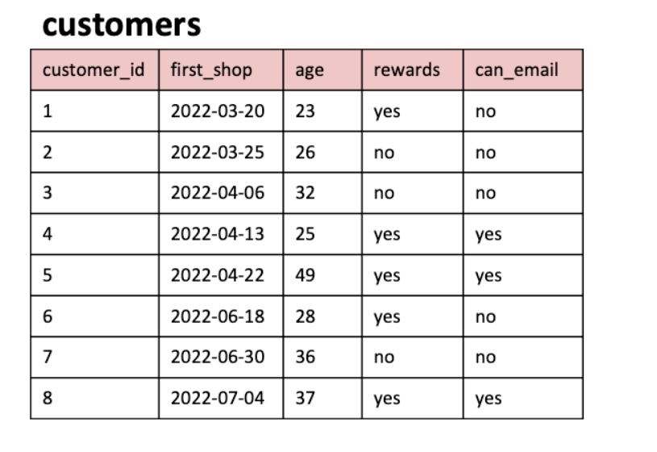

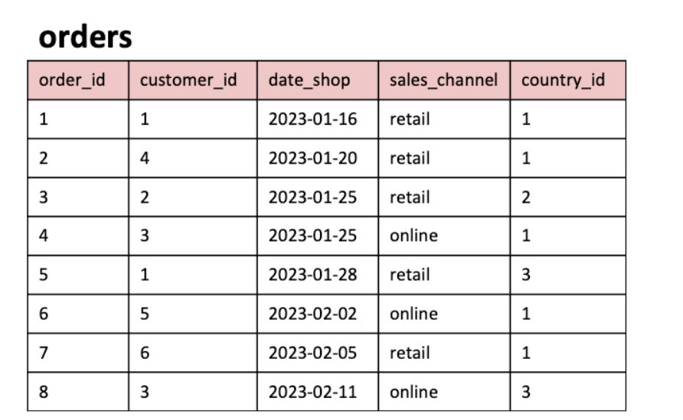

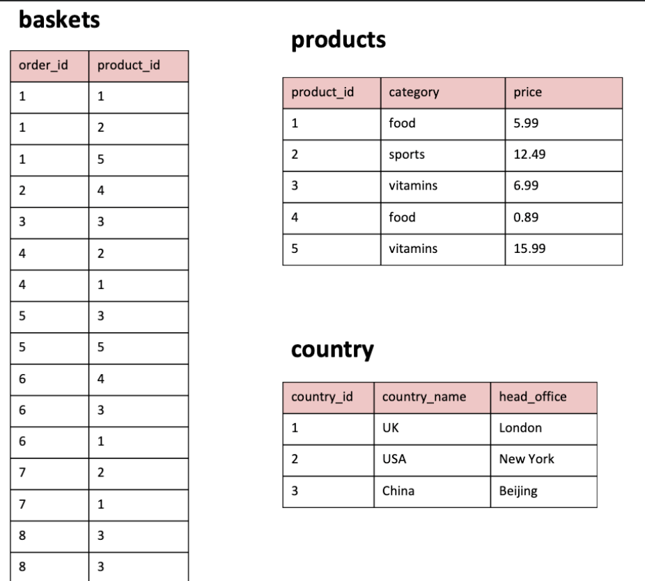

# **QUESTION 1: WHAT ARE THE NAMES OF ALL THE COUNTRIES IN THE COUNTRY TABLE?**

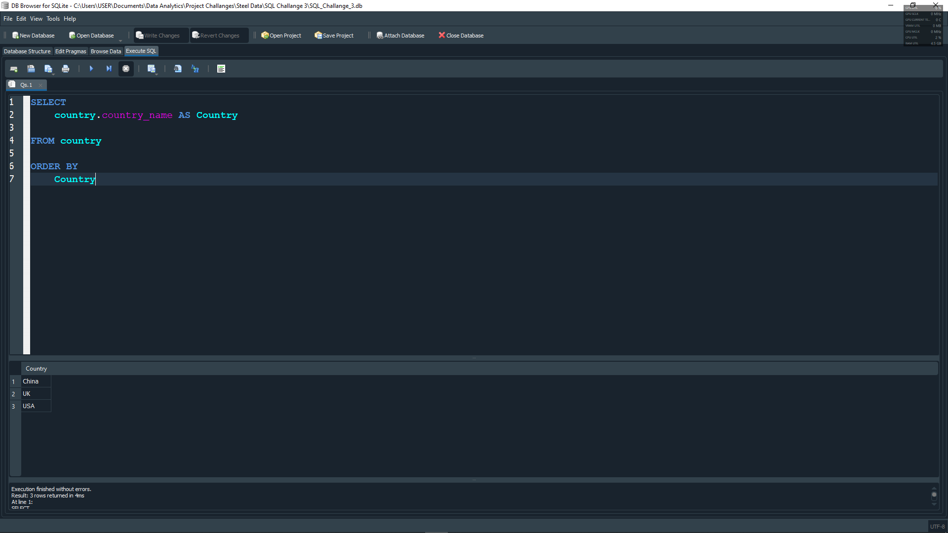

The name of all the countries in the country table are:

* **China**
* **United Kingdom**
* **United States of America**

# **QUESTION 2: WHAT IS THE TOTAL NUMBER OF CUSTOMERS IN THE CUSTOMER TABLE?**

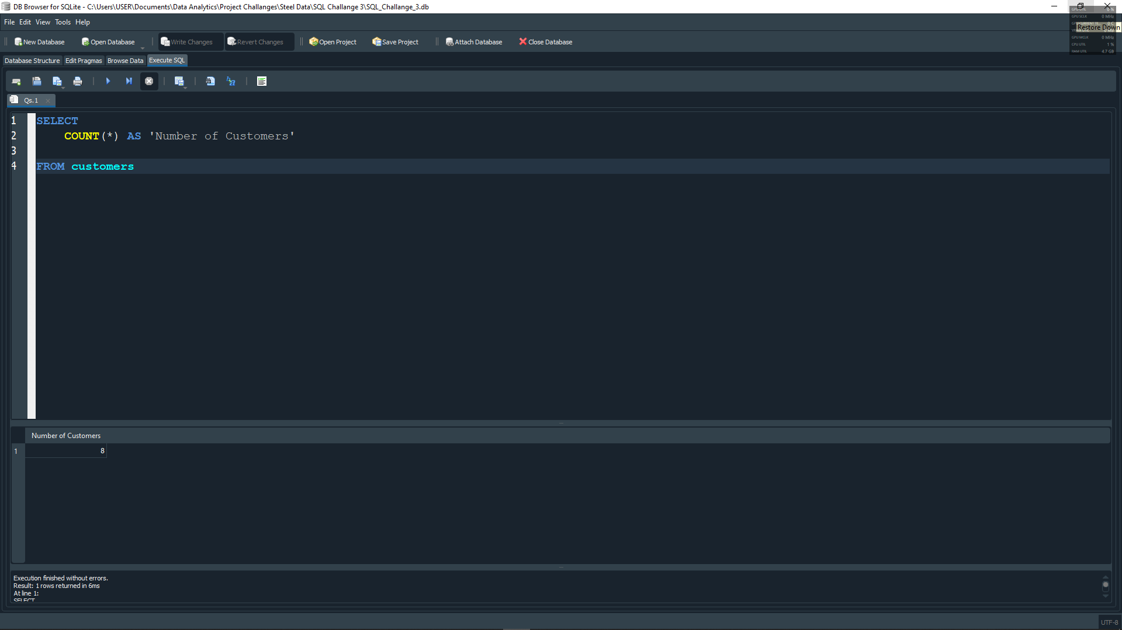

The number of customers in the customer table is **8**.

# **QUESTION 3: WHAT IS THE AVERAGE AGE OF CUSTOMERS WHO CAN RECEIVE MARKETING EMAIL (‘can_email’ is set to ‘yes’)?**

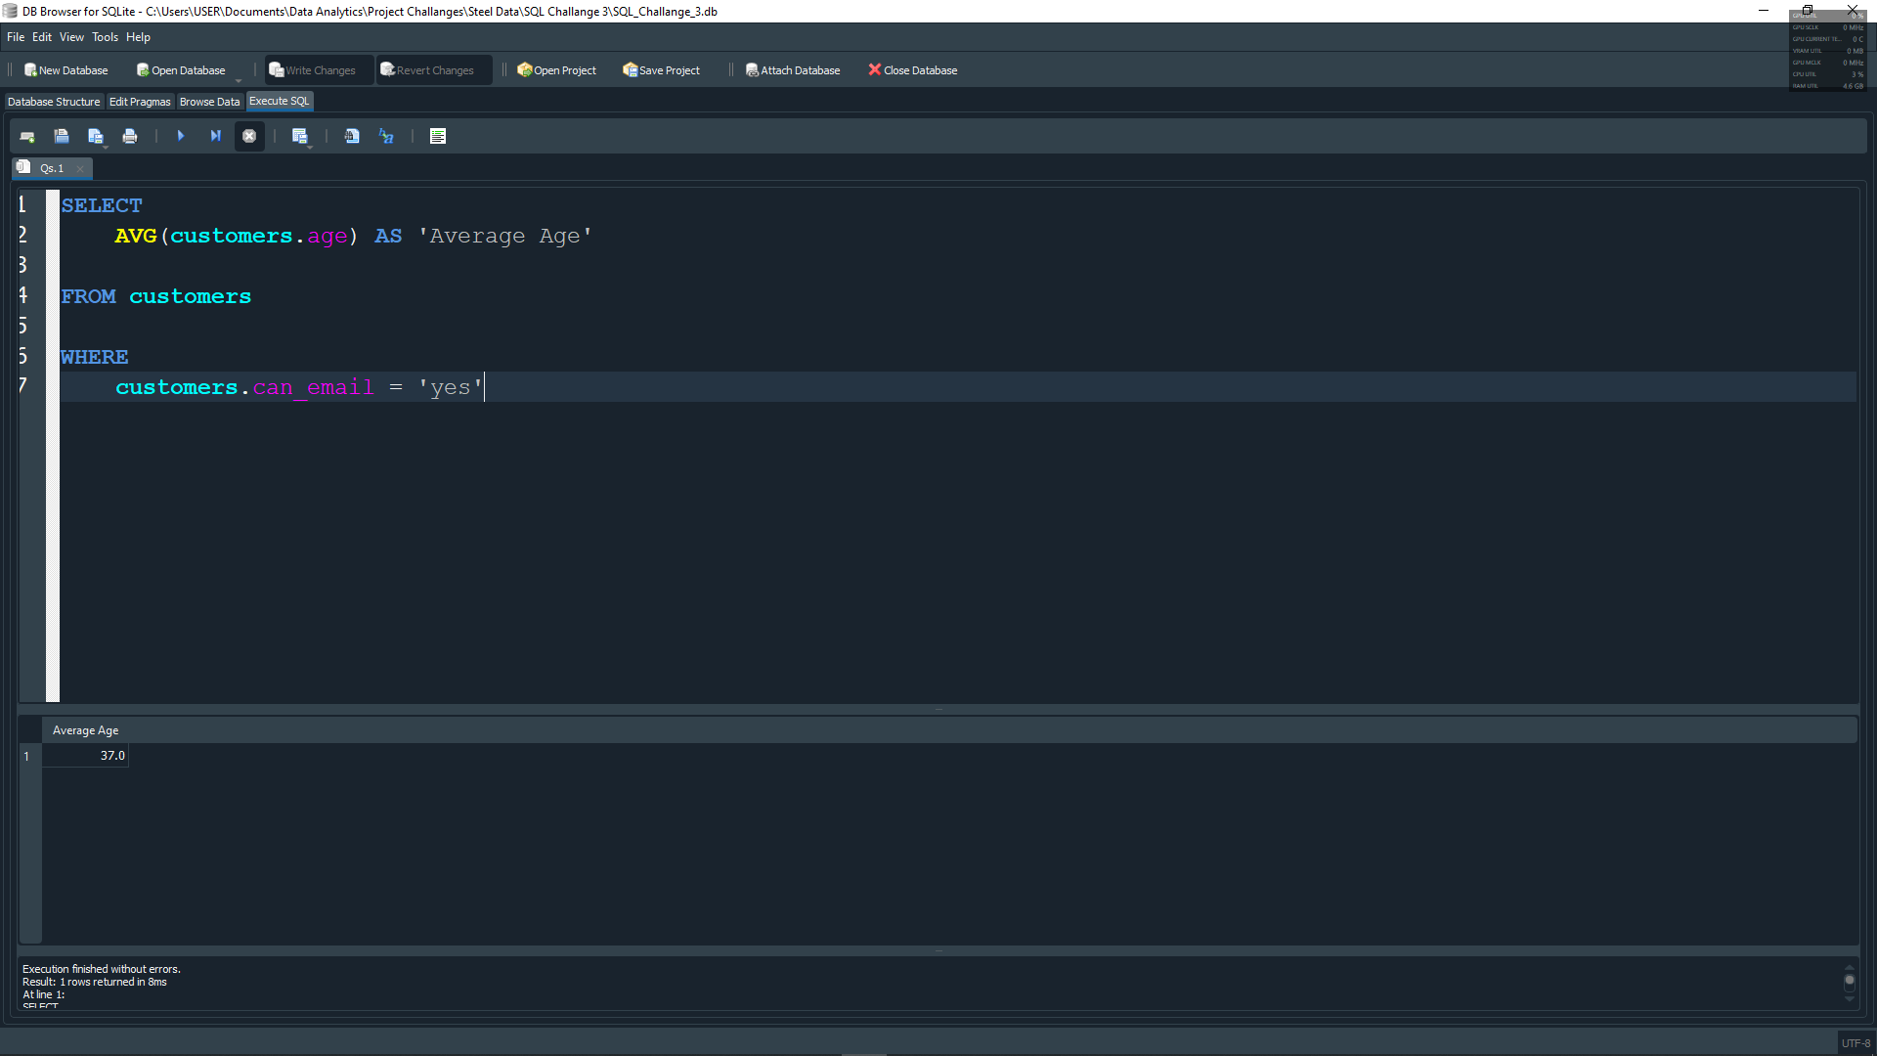

The average age of customers who can receive marketing email is **37 years old**.

# **QUESTION 4: HOW MANY ORDERS WERE MADE BY CUSTOMERS AGED 30 OR OLDER?**

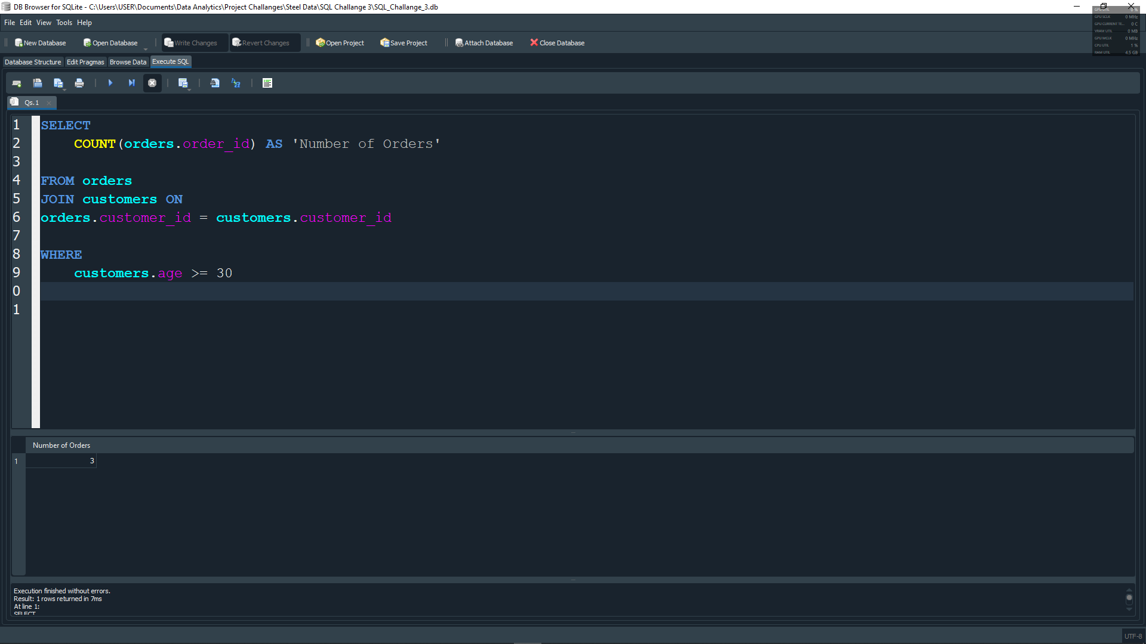

The number of orders that were made by customers aged 30 or older are **3**

# **QUESTION 5: WHAT IS THE TOTAL REVENUE GENERATED BY EACH PRODUCT CATEGORY?**

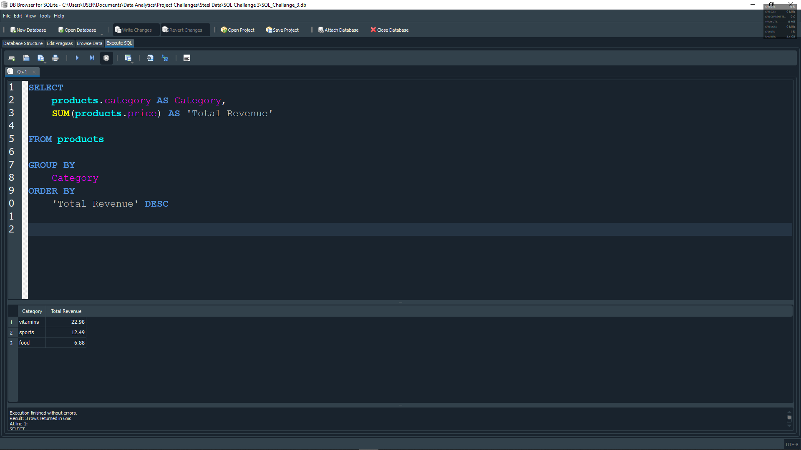

The total revenue generated by each product category are:

* **Vitamins: $22.98**
* **Sports: $12.49**
* **Food: $6.88**

# **QUESTION 6: WHAT IS THE AVERAGE OF PRODUCTS IN THE ‘FOOD’ CATEGORY?**

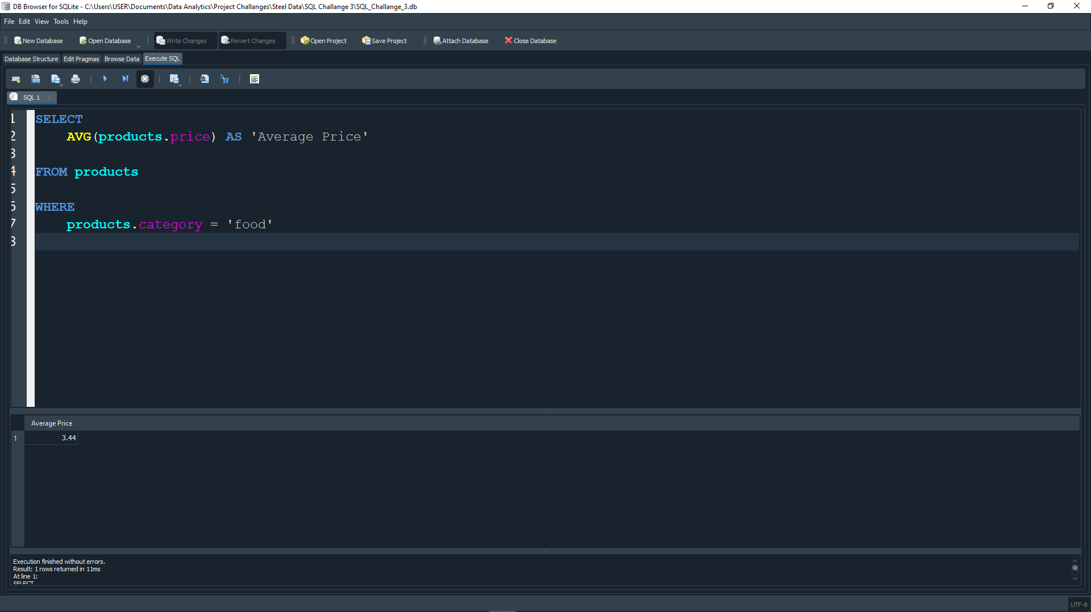

The average price of products in the ‘food’ category group is **$3.44.**

# **QUESTION 7: HOW MANY ORDERS WERE MADE IN EACH SALES CHANNEL (sales_channel COLUMN) IN THE ORDERS TABLE?**

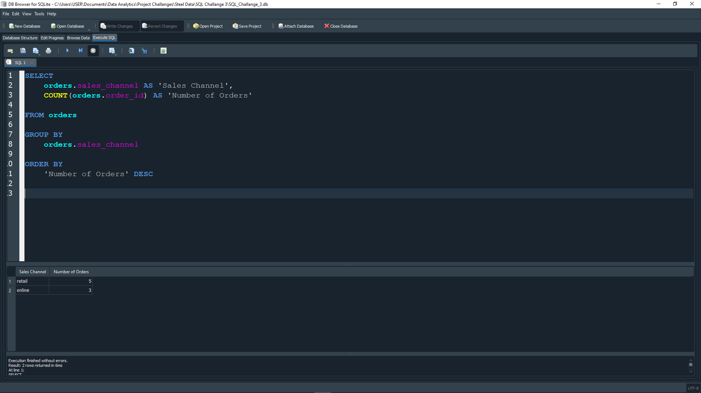

Number of orders made in each sales channel are:

* **Retail: 5**
* **Online: 3**

# **QUESTION 8: WHAT IS THE DATE OF THE LATEST ORDER MADE BY A CUSTOMER WHO CAN RECEIVE MARKETING EMAILS?**

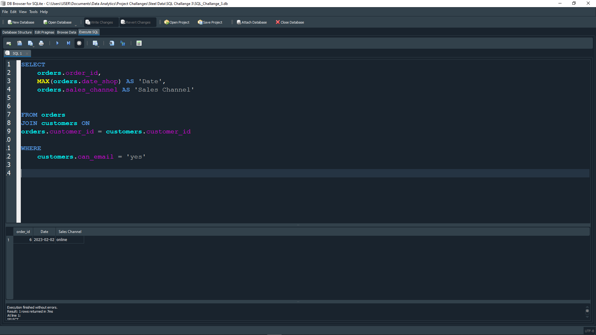

The date of the latest order made by a customer who can receive marketing emails are **2nd February, 2023**

# **QUESTION 9: WHAT IS THE NAME OF THE COUNTRY WITH THE HIGHEST NUMBER OF ORDERS?**

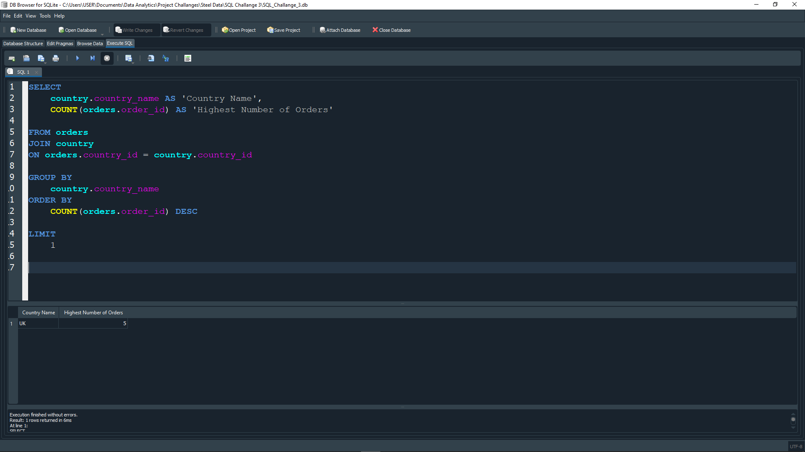

The name of the country with the highest number of orders is **United Kingdom**.

# **QUESTION 10: WHAT IS THE AVERAGE AGE OF CUSTOMERS WHO MADE ORDERS IN THE ‘vitamins’ PRODUCT CATEGORY?**

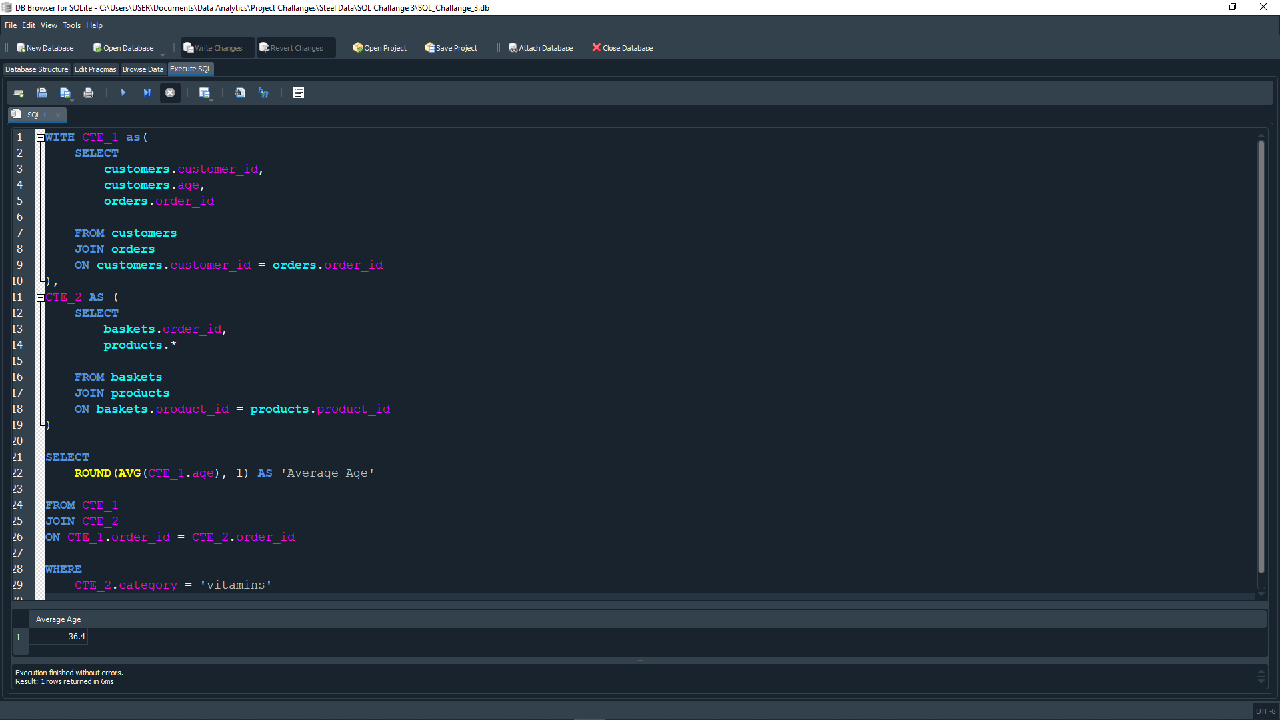

The average age of customers who made orders in the ‘vitamins’ product category is **36 years old**.